**פרויקט VHDL בקורס "תכן לוגי ומבוא**

גאסם גריפאת:318475902

סלימאן קזל:206702128

**מבוא :**

**המערכת שיש לממש בפרויקט**

* **מטרת המערכת:** **יש לממש מערכת לחישוב ממוצע ציונים לקורסים תוך שימוש בעיקרון הפרדת מסלול נתונים ובקר.**
* **המערכת**:

המערכת בנויה על עקרון ההפרדה של מסלול נתונים ובקר.

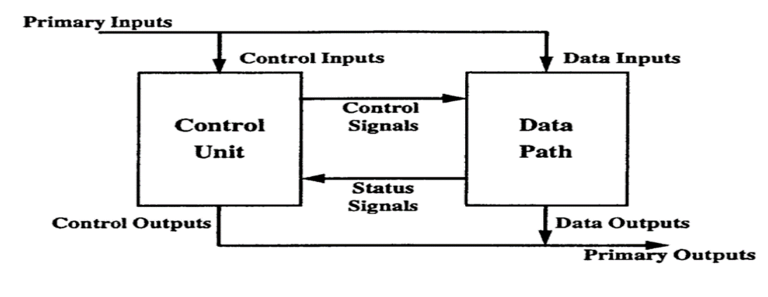לכן היא מורכבת ממסלול נתונים בנפרד ו בקר (המוח של המערכת) ששולט במסלול נתונים בעזרת אותות בקרה.

**מימוש מסלול הנתונים:**

הנתונים במערכת ייוצגו בשיטת המשלים ל- 2 ב- 16 סיביות

**תרשים למסלול הנתונים:**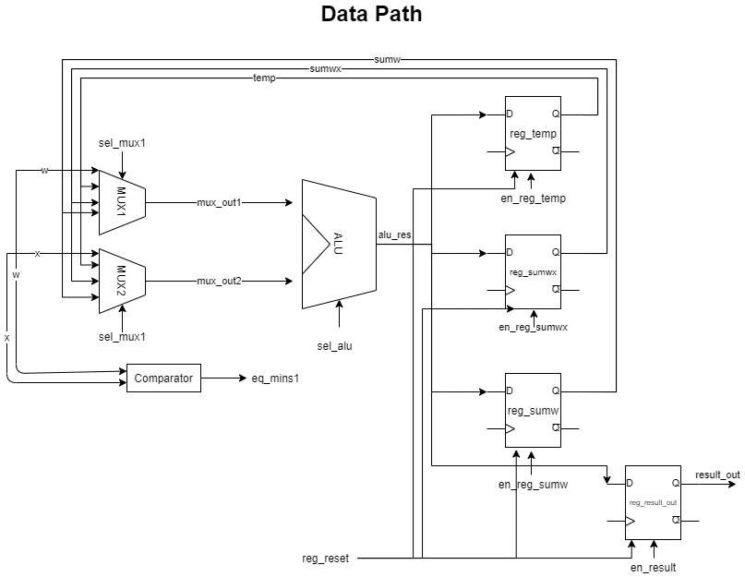

**תיאור היררכי של הקבצים בפרוייקט:**

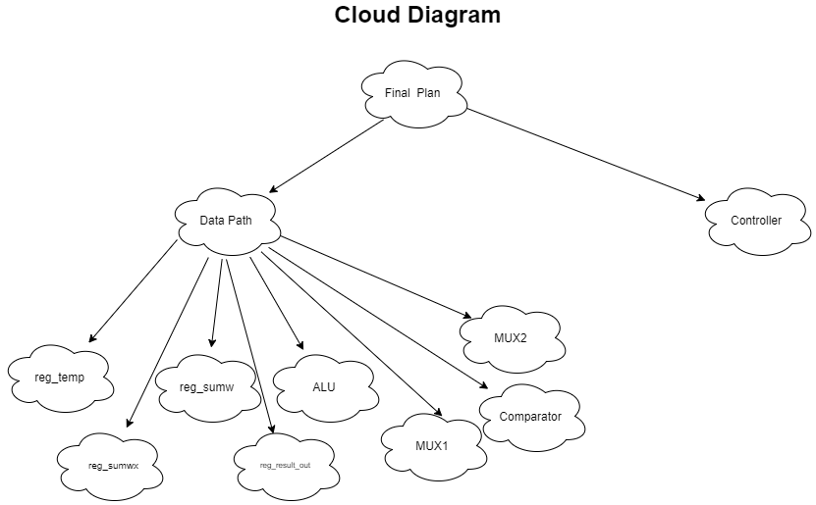

**יחידות המרכיבות את מסלול הנתונים:**

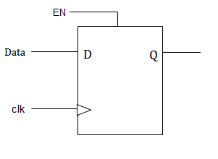**D Flip Flop**

**הסבר:**

**קוד VHDL:**

library IEEE;

use IEEE.std_logic_1164.all;

use IEEE.numeric_std.all;

entity df_f is

    port(

        clock: in std_logic;

        reset: in std_logic;

        enable: in std_logic;

        d: in std_logic_vector(15 downto 0);

        q: out std_logic_vector(15 downto 0):= (others=> '0')

    );

end df_f;

architecture arch_df_f of df_f is

begin

    process(clock,enable,d,reset) begin

        if(reset = '1') then

                q <= (others=> '0');

        elsif rising_edge(clock) then

            if(enable = '1') then

                q <= d after 2 ps;

            end if;

        end if;

    end process;

end arch_df_f;

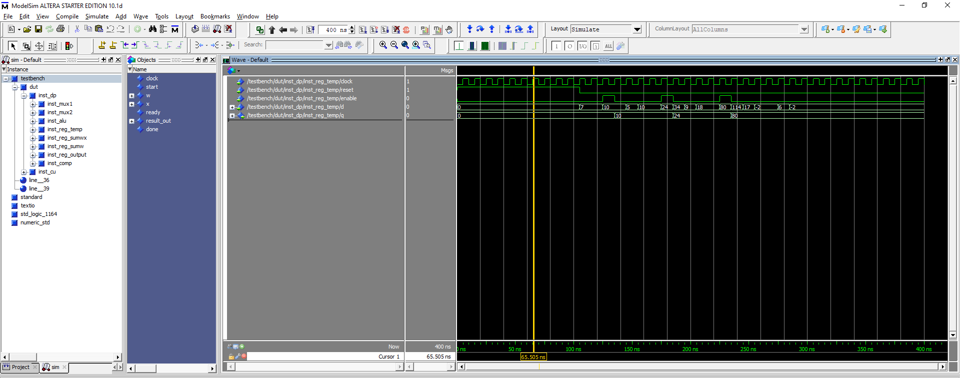

**Mux**

**הסבר:**

.ALU של ה תפקיד הבורר הוא לבחור איזו תוצאה תצא החוצה מתוך הריגיסטרים אל הכניסה

**קוד VHDL:**

library IEEE;

use IEEE.std_logic_1164.all;

use IEEE.numeric_std.all;

entity mux is

    port(

        mux_in0: in std_logic_vector(15 downto 0);

        mux_in1: in std_logic_vector(15 downto 0);

        mux_in2: in std_logic_vector(15 downto 0);

        mux_in3: in std_logic_vector(15 downto 0);

        mux_sel: in std_logic_vector(1 downto 0);

        mux_out: out std_logic_vector(15 downto 0)

    );

end mux;

architecture arch_mux of mux is

begin

    process (mux_sel,mux_in0,mux_in1,mux_in2,mux_in3) begin

        case mux_sel is

            when "00" => mux_out <= mux_in0 after 2 ps;

            when "01" => mux_out <= mux_in1 after 2 ps ;

            when "10" => mux_out <= mux_in2 after 2 ps ;

            when "11" => mux_out <= mux_in3 after 2 ps ;

            when others => mux_out <= (others=> '0');

        end case;

    end process;

end arch_mux;

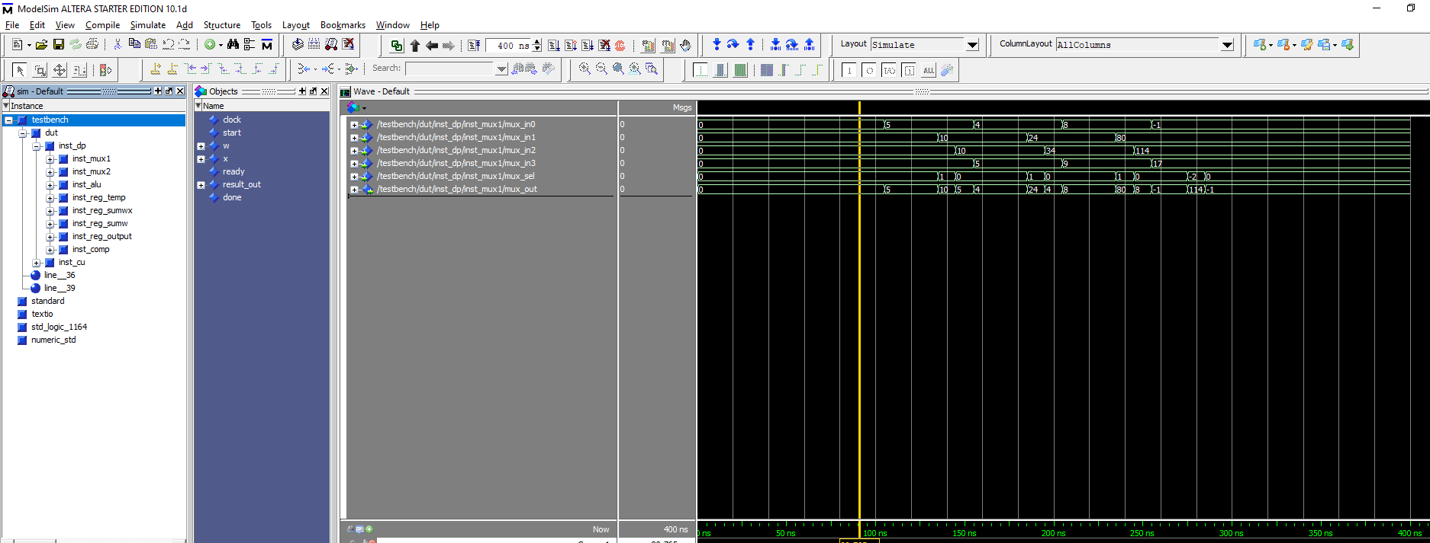

# ***Comparator***

## **VHDL Code:**

library IEEE;

use IEEE.std_logic_1164.all;

use IEEE.numeric_std.all;

entity comparator is

    port(

        w: in std_logic_vector(15 downto 0);

        x: in std_logic_vector(15 downto 0);

        eq_mins1: out std_logic

    );

end comparator;

architecture arch_comparator of comparator is

begin

    eq_mins1 <= '1' when ((signed(x) = to_signed(-1,x'length)) OR (signed(w) = to_signed(-1,w'length))) else '0';

end  arch_comparator;

## Simulation Screenshot:

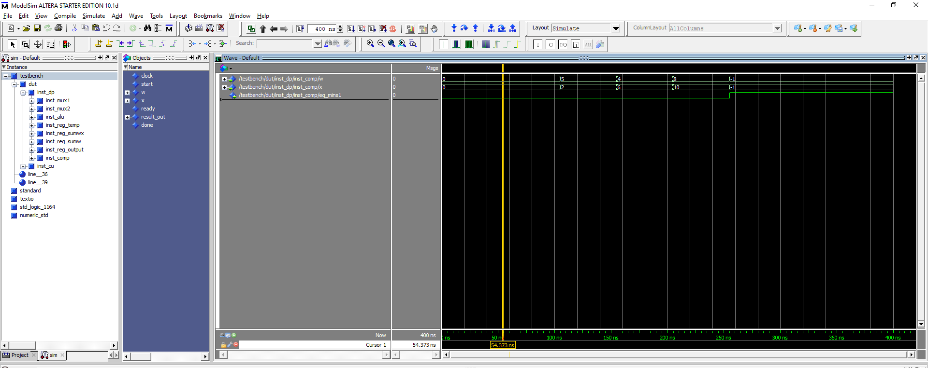

# **ALU**

## **VHDL Code:**

library ieee;

use ieee.std_logic_1164.all;

USE ieee.numeric_std.ALL;

entity alu is

port(

    a,b : in std_logic_vector(15 downto 0);

    opcode : in std_logic_vector(1 downto 0);

    res: out std_logic_vector(15 downto 0)

);

end;

architecture behave of alu is

signal tmp : integer;

begin

P1: process(opcode, a, b)

 begin

  C1: case opcode is

      when "00" => tmp <= to_integer(signed(a))+to_integer(signed(b)) after 5 ps;

      when "01" => tmp <= to_integer(signed(a))*to_integer(signed(b)) after 7 ps;

      when "10" => tmp <= to_integer(signed(a))/to_integer(signed(b)) after 10 ps;

      when others => tmp <= 0;

  end case C1;

 end process;

res <= std_logic_vector(to_signed(tmp, res'length));

end behave;

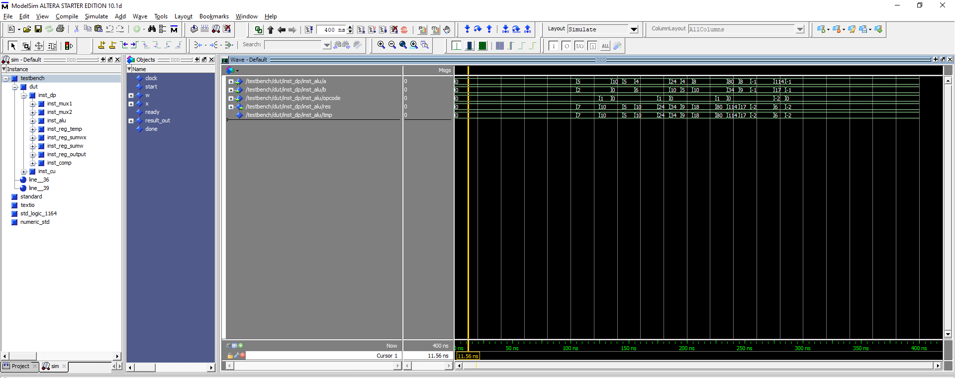

# **Data Path**

**הסבר:**

יחידות המרכיבות את מסלול הנתונים.

## **VHDL Code:**

library IEEE;

use IEEE.std_logic_1164.all;

use IEEE.numeric_std.all;

entity datapath is

    port(

        -- inputs

        clock: in std_logic;

        start: in std_logic;

        w: in std_logic_vector(15 downto 0);

        x: in std_logic_vector(15 downto 0);

        en_reg_temp: in std_logic;

        en_reg_sumwx: in std_logic;

        en_reg_sumw: in std_logic;

        en_result: in std_logic;

        sel_mux1: in std_logic_vector(1 downto 0);

        sel_mux2: in std_logic_vector(1 downto 0);

        sel_alu: in std_logic_vector(1 downto 0);

        reg_reset: in std_logic;

        -- outputs

        eq_mins1: out std_logic; -- stop condition

        result_out: out std_logic_vector(15 downto 0)

    );

end datapath;

architecture arch_datapath of datapath is

    -- Signals

    signal mux_out1: std_logic_vector(15  downto 0);

    signal mux_out2: std_logic_vector(15  downto 0);

    signal alu_res: std_logic_vector(15 downto 0);

    signal temp: std_logic_vector(15 downto 0);

    signal sumwx: std_logic_vector(15 downto 0);

    signal sumw: std_logic_vector(15 downto 0);

begin

    -- First mux

    inst_mux1: entity work.mux

        port map(

            mux_in0 => w,

            mux_in1 => temp,

            mux_in2 => sumwx,

            mux_in3 => sumw,

            mux_sel => sel_mux1,

            mux_out => mux_out1

        );

    --second mux

    inst_mux2: entity work.mux

        port map(

            mux_in0 => x,

            mux_in1 => temp,

            mux_in2 => sumwx,

            mux_in3 => sumw,

            mux_sel => sel_mux2,

            mux_out => mux_out2

        );

    -- ALU

    inst_alu: entity work.alu

        port map(

            a => mux_out1,

            b => mux_out2,

            opcode => sel_alu,

            res => alu_res

        );

    -- Registers

    inst_reg_temp: entity work.df_f

        port map(

            clock => clock,

            reset => reg_reset,

            enable => en_reg_temp,

            d => alu_res,

            q => temp

        );

    inst_reg_sumwx: entity work.df_f

        port map(

            clock => clock,

            reset => reg_reset,

            enable => en_reg_sumwx,

            d => alu_res,

            q => sumwx

        );

    inst_reg_sumw: entity work.df_f

        port map(

            clock => clock,

            reset => reg_reset,

            enable => en_reg_sumw,

            d => alu_res,

            q => sumw

        );

    inst_reg_output: entity work.df_f

        port map(

            clock => clock,

            reset => reg_reset,

            enable => en_result,

            d => alu_res,

            q => result_out

        );

    -- comparator

    inst_comp: entity work.comparator

        port map(

            w => w,

            x => x,

            eq_mins1 => eq_mins1

        );

end arch_datapath;

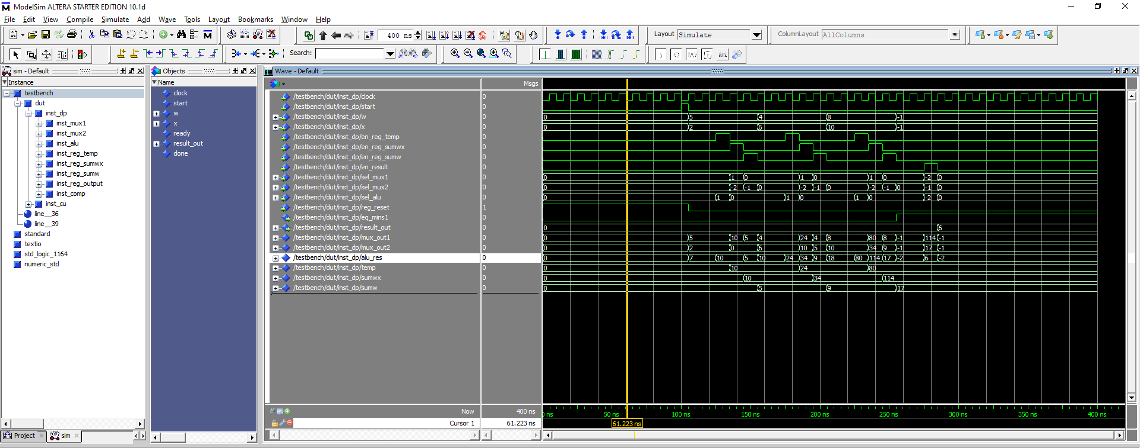

# **Control Unit**:

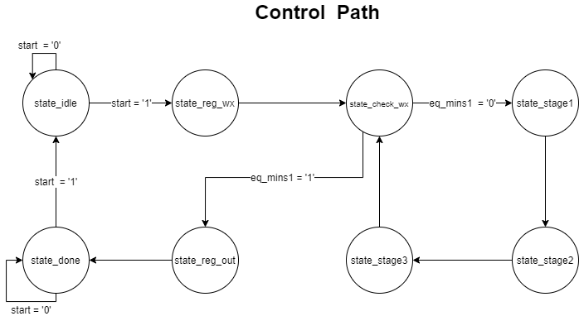

|  |  |  |  |  |  |  |  |  |
| --- | --- | --- | --- | --- | --- | --- | --- | --- |
|  | **state_idle** | **state_reg_wx** | **state_check_wx** | **state_stage1** | **state_stage2** | **state_stage3** | **state_reg_out** | **state_done** |
| en_reg_temp | 0 | 0 | 0 | 1 | 0 | 0 | 0 | 0 |
| en_reg_sumwx | 0 | 0 | 0 | 0 | 1 | 0 | 0 | 0 |
| en_reg_sumw | 0 | 0 | 0 | 0 | 0 | 1 | 0 | 0 |
| en_result | 0 | 0 | 0 | 0 | 0 | 0 | 1 | 0 |
| sel_mux1 | 0 | 0 | 0 | 0 | 1 | 0 | 10 | 0 |
| sel_mux2 | 0 | 0 | 0 | 0 | 10 | 11 | 11 | 0 |
| sel_alu | 0 | 0 | 0 | 1 | 0 | 0 | 10 | 0 |
| reg_reset | 1 | 0 | 0 | 0 | 0 | 0 | 0 | 0 |
| done | 0 | 0 | 0 | 0 | 0 | 0 | 0 | 1 |
| ready | 0 | 1 | 0 | 0 | 0 | 0 | 0 | 0 |

## **VHDL Code:**

library IEEE;

use IEEE.std_logic_1164.all;

use IEEE.numeric_std.all;

entity cu is

    port(

        clock: in std_logic;

        start: in std_logic;

        eq_mins1: in std_logic; -- stop condition

        --outputs

        en_reg_temp: out std_logic;

        en_reg_sumwx: out std_logic;

        en_reg_sumw: out std_logic;

        en_result: out std_logic;

        sel_mux1: out std_logic_vector(1 downto 0);

        sel_mux2: out std_logic_vector(1 downto 0);

        sel_alu: out std_logic_vector(1 downto 0);

        reg_reset: out std_logic;

        ready: out std_logic;

        done: out std_logic

    );

end cu;

architecture arch_cu of cu is

    -- define FSM

    type states is(

        state_idle, -- wait for start

        state_reg_wx, -- input w and x

        state_check_wx, -- check if w or x is -1 ?

        state_stage1, -- if not stopping condition -- then temp = w * x

        state_stage2, -- wx = wx + temp

        state_stage3, -- w = w + in_w

        state_reg_out, -- state to register output

        state_done -- output is ready

    );

    signal p_state: states:= state_idle;

begin

    process(clock,start,eq_mins1) begin

        if rising_edge(clock) then

            case(p_state) is

                when state_idle =>

                    if(start = '1') then

                        p_state <= state_reg_wx;

                    end if;

                when state_reg_wx =>

                    p_state <= state_check_wx;

                when state_check_wx =>

                    if(eq_mins1 = '1') then

                        p_state <= state_reg_out;

                    else

                        p_state <= state_stage1;

                    end if;

                when state_stage1 =>

                    p_state <= state_stage2;

                when state_stage2 =>

                    p_state <= state_stage3;

                when state_stage3 =>

                    p_state <= state_reg_wx;

                when state_reg_out =>

                    p_state <= state_done;

                when state_done =>

                    if(start = '1') then

                        p_state <= state_idle;

                    end if;

                when others =>

                    p_state <= state_idle;

            end case;

        end if;

    end process;

    --outputs

    process(p_state) begin

        case (p_state) is

            when state_idle =>

                en_reg_temp <= '0';

                en_reg_sumwx <= '0';

                en_reg_sumw <= '0';

                en_result  <= '0';

                sel_mux1 <= "00";

                sel_mux2 <= "00";

                sel_alu <= "00";

                reg_reset <= '1';

                done <= '0';

                ready <= '0';

            when state_reg_wx =>

                en_reg_temp <= '0';

                en_reg_sumwx <= '0';

                en_reg_sumw <= '0';

                en_result  <= '0';

                sel_mux1 <= "00";

                sel_mux2 <= "00";

                sel_alu <= "00";

                reg_reset <= '0';

                done <= '0';

                ready <= '1';

            when state_check_wx =>

                en_reg_temp <= '0';

                en_reg_sumwx <= '0';

                en_reg_sumw <= '0';

                en_result  <= '0';

                sel_mux1 <= "00";

                sel_mux2 <= "00";

                sel_alu <= "00";

                reg_reset <= '0';

                done <= '0';

                ready <= '0';

            when state_stage1 =>

                en_reg_temp <= '1';

                en_reg_sumwx <= '0';

                en_reg_sumw <= '0';

                en_result  <= '0';

                sel_mux1 <= "00";

                sel_mux2 <= "00";

                sel_alu <= "01";

                reg_reset <= '0';

                done <= '0';

                ready <= '0';

            when state_stage2 =>

                en_reg_temp <= '0';

                en_reg_sumwx <= '1';

                en_reg_sumw <= '0';

                en_result  <= '0';

                sel_mux1 <= "01";

                sel_mux2 <= "10";

                sel_alu <= "00";

                reg_reset <= '0';

                done <= '0';

                ready <= '0';

            when state_stage3 =>

                en_reg_temp <= '0';

                en_reg_sumwx <= '0';

                en_reg_sumw <= '1';

                en_result  <= '0';

                sel_mux1 <= "00";

                sel_mux2 <= "11";

                sel_alu <= "00";

                reg_reset <= '0';

                done <= '0';

                ready <= '0';

            when state_reg_out =>

                en_reg_temp <= '0';

                en_reg_sumwx <= '0';

                en_reg_sumw <= '0';

                en_result  <= '1';

                sel_mux1 <= "10";

                sel_mux2 <= "11";

                sel_alu <= "10";

                reg_reset <= '0';

                done <= '0';

                ready <= '0';

            when state_done =>

                en_reg_temp <= '0';

                en_reg_sumwx <= '0';

                en_reg_sumw <= '0';

                en_result  <= '0';

                sel_mux1 <= "00";

                sel_mux2 <= "00";

                sel_alu <= "00";

                reg_reset <= '0';

                done <= '1';

                ready <= '0';

            when others =>

                en_reg_temp <= '0';

                en_reg_sumwx <= '0';

                en_reg_sumw <= '0';

                en_result  <= '0';

                sel_mux1 <= "00";

                sel_mux2 <= "00";

                sel_alu <= "00";

                reg_reset <= '0';

                done <= '0';

                ready <= '0';

        end case;

    end process;

end arch_cu;

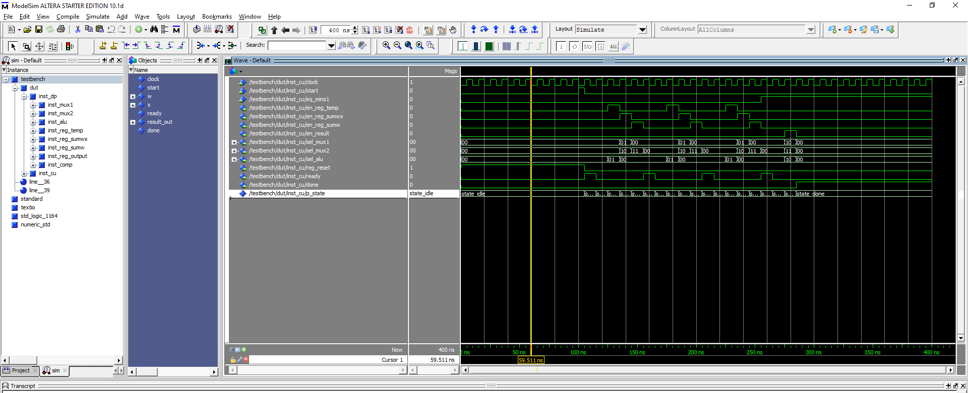

# **Final Plan**

## **VHDL Code:**

library IEEE;

use IEEE.std_logic_1164.all;

use IEEE.numeric_std.all;

entity top is

    port (

        --inputs

        clock: in std_logic;

        start: in std_logic;

        w: in std_logic_vector(15 downto 0);

        x: in std_logic_vector(15 downto 0);

        --outputs

        ready: out std_logic;

        result_out: out std_logic_vector(15 downto 0);

        done: out std_logic

    );

end top;

architecture arch_top of top is

    -- Intermediate Signals

    signal eq_mins1: std_logic;

    signal en_regw: std_logic;

    signal en_regx: std_logic;

    signal en_reg_temp: std_logic;

    signal en_reg_sumwx: std_logic;

    signal en_reg_sumw: std_logic;

    signal en_result: std_logic;

    signal sel_mux1: std_logic_vector(1 downto 0);

    signal sel_mux2: std_logic_vector(1 downto 0);

    signal sel_alu: std_logic_vector(1 downto 0);

    signal reg_reset: std_logic;

begin

    -- DataPath

    inst_dp: entity work.datapath

        port map(

            clock => clock,

            start => start,

            w => w,

            x => x,

            eq_mins1 => eq_mins1,

            en_reg_temp => en_reg_temp,

            en_reg_sumwx => en_reg_sumwx,

            en_reg_sumw => en_reg_sumw,

            en_result => en_result,

            sel_mux1 => sel_mux1,

            sel_mux2 => sel_mux2,

            sel_alu => sel_alu,

            reg_reset => reg_reset,

            result_out => result_out

        );

    -- Control Unit

    inst_cu: entity work.cu

        port map(

            clock => clock,

            start => start,

            eq_mins1 => eq_mins1,

            en_reg_temp => en_reg_temp,

            en_reg_sumwx => en_reg_sumwx,

            en_reg_sumw => en_reg_sumw,

            en_result => en_result,

            sel_mux1 => sel_mux1,

            sel_mux2 => sel_mux2,

            sel_alu => sel_alu,

            reg_reset => reg_reset,

            ready => ready,

            done => done

        );

end arch_top;

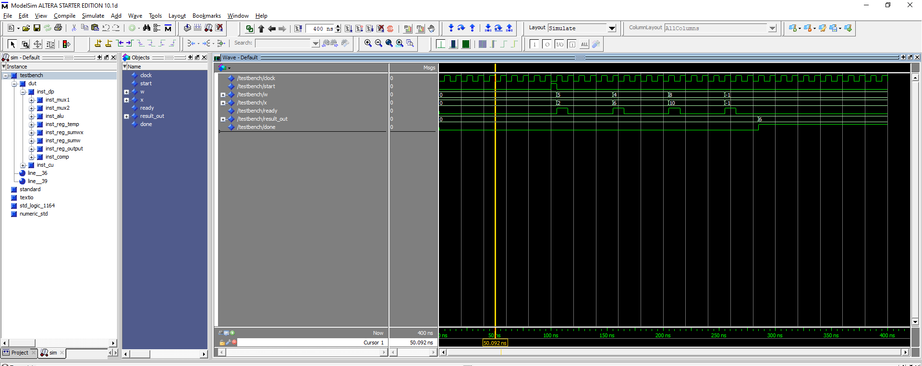

# **TESTBENCH**

# VHDL CODE:

library IEEE;

use IEEE.std_logic_1164.all;

use IEEE.numeric_std.all;

entity testbench is

end testbench;

architecture arch_testbench of testbench is

    --intermediate signals

    --inputs

    signal clock: std_logic:= '0';

    signal start: std_logic:= '0';

    signal w: std_logic_vector(15 downto 0):= (others => '0');

    signal x: std_logic_vector(15 downto 0):= (others => '0');

    --outputs

    signal ready: std_logic;

    signal result_out: std_logic_vector(15 downto 0);

    signal done: std_logic;

begin

    --design under test

    dut: entity work.top

        port map(

        --inputs

        clock => clock,

        start => start,

        w => w,

        x => x,

        --outputs

        ready => ready,

        result_out => result_out,

        done => done

        );

    --100 Mhz clock generator

        clock <= NOT clock after 5 ns;

    --testing process

    process begin

        wait for 100 ns;

        start <= '1';

        wait until (ready = '1');

        start <= '0';

        -- first course

        x <= x"0002";

        w <= x"0005";

        wait until (ready = '1');

        -- Second course

        x <= x"0006";

        w <= x"0004";

        wait until (ready = '1');

        -- Third course

        x <= x"000a";

        w <= x"0008";

        wait until (ready = '1');

        -- stop condition

        x <= std_logic_vector(to_signed(-1,x'length));

        w <= std_logic_vector(to_signed(-1,x'length));

        wait until (done = '1');

        wait for 100 ns;

        wait;

    end process;

end arch_testbench;